 | This Referral and needs assessment is required to be completed to join our services department and access programmes such as Youth Projects, Best Buddies and BASE provision (*Base can only be accessed via a Day opportunities Referral).  All information will be treated in strictest confidence. We will ask for more information if we need it for each programme.

Individuals with a learning disability, autism, and/or who are neurodivergent can access our services.
To help us understand whether you meet the criteria for specific projects, please provide more information below. This may include details of any confirmed diagnosis, if you have one (this is not always required).
A member of our team may contact you to discuss your application further.
 | Circle below |  | Diagnosed, Pending, Self-Diagnosed…  please state below
Do you have a learning disability? | Yes | No
Do you have ASD? | Yes | No
Do you have any neurodiversity’s? | Yes | No
Other? (please state) | Yes | No

Tell us more about your disability (Learning and Physical, if any) any other conditions and how they affect you (e.g. poor concentration, noise sensitivity, excellent memory, restricted diet, needs information written down – anything about your condition that you think it’s important for us to know)

Service you would like to be referred for: Please tick the ones you would like
BLAST – (Youth provision, 8-18)
HUB (Youth drop in club, 12-18)
Best Buddies (Friendship programme, 18+)
Base (Daily activity provision) *Day Opportunity Referral only
Heroes+ (Youth Provision, 14-24)
LIVE (Self-Directed Support, Project pending)
Unsure which project at this time
VOICE Advocacy Service* *Please request separate form

Referrer Details (unless referring self) e.g. Social Worker, Day Opportunity Coordinator
Referrer Name
Organisation
Contact Telephone Number
Email address
Is the person aware of this Referral? | ☐Yes | ☐No
Has the person given consent for the referral?  If no please explain below… | ☐Yes | ☐No

Applicant Details
Name
Address
Postcode |  | Date of Birth
Home Phone Number
Own Mobile Number
Email Address
DO you use social media (please circle) | YES | NO
Preferred form of contact e.g. text, call, via parent/carer etc

Tell us a little more about you
Tell us about any hobbies, interests, college or special talents you have…

Medical
Person takes medication:  □ Independently  □ Needs prompting  PLEASE DETAIL BELOW  Person has the following medical conditions which the provider should be aware of :  ______________________________________________________  ___________________________  ___________________________  ______________________________________________________  Allergies: ______________________________________________________  If relevant, reaction to allergy  ___________________________ | Seizure Disorder: □ Yes □ No  Type: ________________  Frequency and Duration: ____________________________________  ________________________________________________________________________  ________________________________________________________________________  Challenges that may occur (attach a more detailed plan to document if necessary): ____________________________________  ________________________________________________________________________  ________________________________________________________________________  ________________________________________________________________________  Call 999 after: ___________________________________

Support Needs…Do you need help with the following?
Factor | Yes | No | Details
Timekeeping – e.g. getting to a place on time/reading the time
Personal Care |  |  | Note -WE cannot provide or support with personal care at any or our projects.
Money management
Memory – remembering things
Planning ahead
Making decisions for yourself
Dexterity – e.g picking up little things, opening things, using scissors
Other….

Support and Supervision
What level of supervision from staff is required? e.g. no supervision needed, occasional, constant etc.

Please explain further:

Support level Requirement SPECIFIC to BASE Project Activity ONLY – please select one…Please ensure the support level requirement matches the supervision requirement above.

□ Staff Support
□ Peer Support
□ Independent

Note – as per Statement of Understanding, referrals initially requiring staff support is on a trial basis only and must be reviewed at 3 months with aim to remove this requirement.
Communication
How do you/the person referred communicate best? e.g. verbal, pictures, written word, gestures, tablet etc.
Please give as much information as possible e.g. simple instruction, allow time to process etc.

Mobility
Tell us about your mobility. e.g. independently mobile, use aids etc.

Behaviour and Safety
Service provider will be expected to manage any behaviour that challenges: The more information you provide the better we can potentially create an environment to support.
Could this individual present with any behaviours that may challenge? □ Yes □ No
If “yes”, please explain below, including any known triggers and strategies to support: e.g. irrational fear of …….., may dart to avoid.

Please complete the table below…
Behaviour: | Always | Mostly | Sometimes | Never | Explanations*
Gets along well with peers
Enjoys social activities
Has good manners
Uses appropriate touch
Self-abuses
Scratches, pinches others
Hits others
Bites others
Uses inappropriate language
Exhibits inappropriate sexual behaviour
Does not like to be touched
Prefers large personal space
Prefers to be alone
May run away or dart
Can cross the road alone
Understands danger
No known behaviours that challenge

*Please elaborate on an attached page if necessary
Ways to calm when upset:

Person’s typical reaction to new people:

Person’s typical reaction to a new environment/situation:

Person’s typical reaction to animals or pets:

Discuss the person’s sense of safety or danger and explain how the provider can effectively support the person: this could include road safety, personal safety, task safety etc.

Other
How did you hear about CAN?

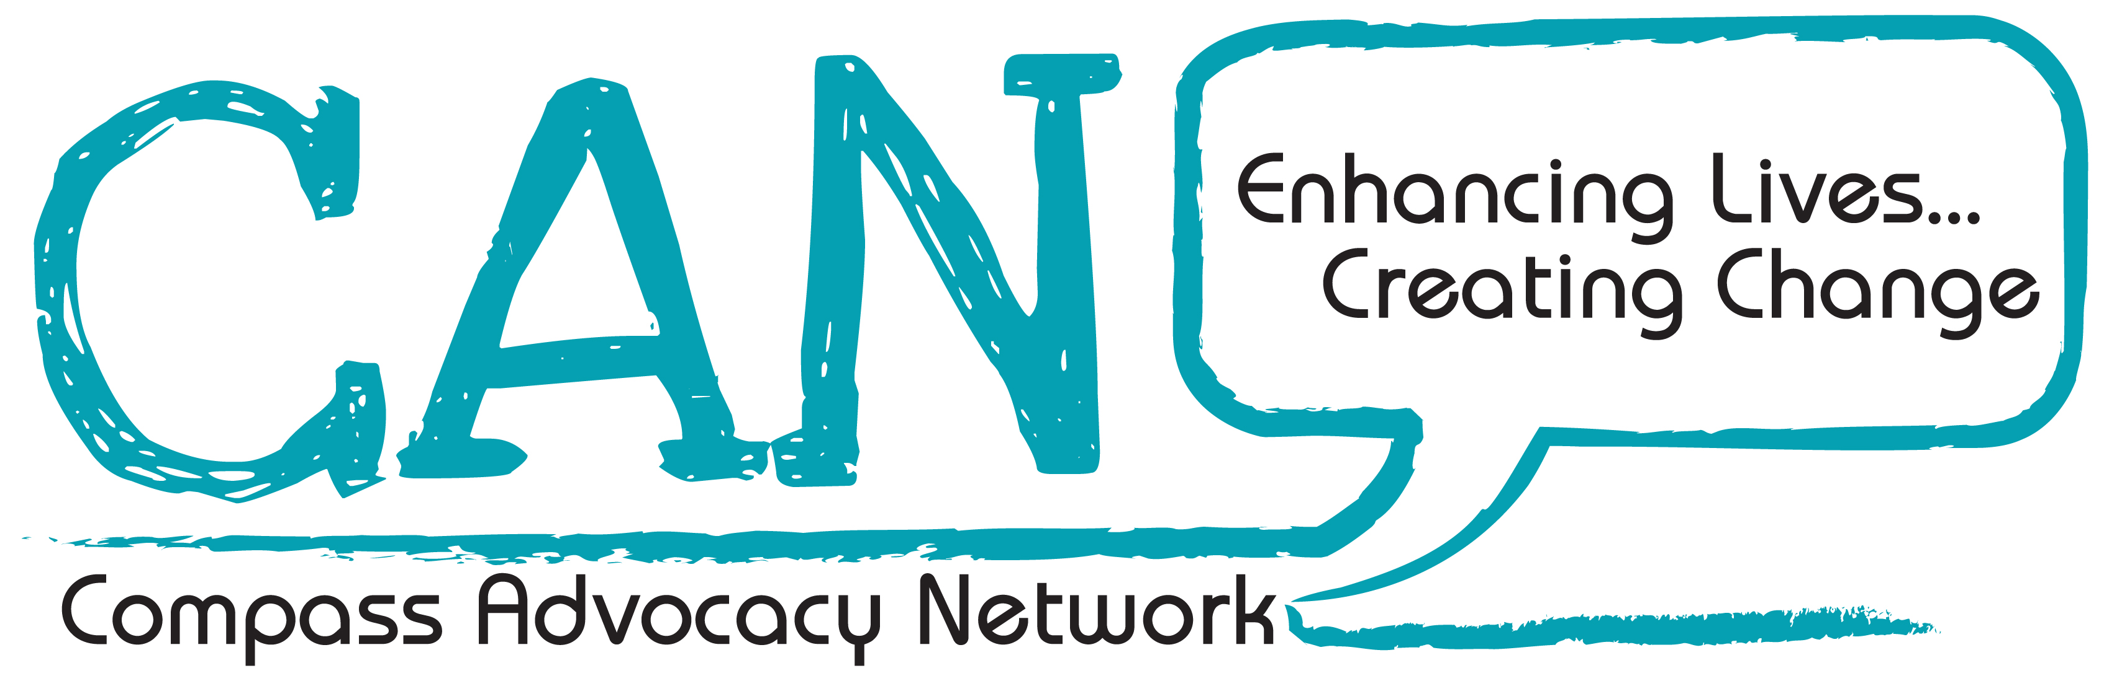
CONSENT FOR MEDIA FORMATS
Compass recognises the need to ensure the welfare and safety of all people in their organisation. In accordance with our child protection and vulnerable adults policy we will not permit photographs, video or other images to be taken without the consent of the individual and if appropriate (if the individual is a minor aged below 18 years), their parents and carers.

Compass will take all steps to ensure that these images are used solely for the purposes they are intended. If you become aware that these images are being used inappropriately, you should inform Compass Advocacy Network Ltd immediately.

I, __________________________________________________________________
(Name in Capitals)
understand fully and agree to give my consent to have my personal image used in various media formats by Compass Advocacy Network Ltd. This consent will cover media formats such as press photographs, local and regional television coverage and national publication of journals and books. I understand that this coverage may be used for the organisation in the use of marketing and promotional materials.

I, __________________________________________________________________
(Name in Capitals of Parent/Carer) if relevant
understand fully and agree to give my consent to Compass Advocacy Network Ltd using my dependents personal image for the purpose of all the media formats detailed above.

Signed: _____________________________________(Individual)
Signed:______________________________________(Parent/Carer) if relevant
Signed:______________________________________(CAN Staff)

Declaration of consent for referral
Organisation: CAN (Compass Advocacy Network)
Participant Name: _________________________________________________
DOB: ________________
I certify that I give consent for a referral to CAN services. I understand that my information will be used by CAN for internal use in relation to my referral.
If the individual cannot give consent a parent/carer can sign on their behalf – please state if this is the case).

Signed: __________________________________________________________
Dated: _______________


NB: The information in this application form will only ever be used for the purposes of CAN and help us to provide you with the right service. We will never share your details. By signing this application, you are agreeing to us storing your data and using it in this way.

Applicant Signature: __________________________________________________
Date: ______________________________________________________________
Parent/Carer/Referrer Signature: (if required)__________________________________

Please return completed forms either via
email to: info@compasspeople.org
or
post to:
FAO Referrals Officer,
Ballymoney, BT53 7DD
For Office Use Only:

Applicant Name: __________________________________________________
Date of Referral: _________________ Date of Initial Visit: _________________
Priority Rating: __________________ Accepted _____YES/NO___________

Date of Commencement: _____________ Signed ________________________

Additional Comments... ________________________________________________________________
________________________________________________________________
________________________________________________________________
________________________________________________________________

